KENDRIYA VIDYALAYA No.2, BOLANGIR

FORMATIVE ASSESSMENT- III (2013-14)

CLASS: III TIME: 1 Hr 30 Min

SUBJECT: MATHS MAX. M: 40

NAME- _______________________________________ DATE: …..../01/2014

Class- III Sec___ Roll No._____ Invigilator’s Sign_______ Examiner’s Sign. ……

|  |  |  |  |  |  |
| --- | --- | --- | --- | --- | --- |
| COMPETENCIES | KNOWLEDGE | UNDERSTANDING | ABILTY IN  COMPUTING | PROBLEM SOLVING ABILITY | OVER ALL GRADE |
|  |  |  |  |  |  |

KNOWLEDGE

A) Circle the heavier one:

1. Shoe or Pencil box
2. Plastic spoon or Steel spoon B) Continue the following patterns
3. 1,3,7,13 , ______ ,_________ , _______
4. 4,8,12,16 , ______ ,_________ , _______
5. 12A, 13B, 14C , ______ ,_________ , _______
6. 40, 80, 120, , ______ ,_________ , _______ C) Fill in the blanks.

24

… X….

……X....

….X…..

…..X…

D) Decode the secret message written below.

I1N2D3I4A5N

_____________________

|  |
| --- |
| 5H5E5L5P 5T5H5E 5N5E5E5D5Y |

_____________________ UNDERSTANDING

1. Fill in the blanks.
   1. 5X18 is 5 times 18 or ___+____+___+____ + _____
   2. 4X20 is 4times 20 or ____+_____+_____ + _____
2. Guess their weight and match .

|  |  |
| --- | --- |
| Elephant | less than ½ kg |
| Cow | 10 kg |
| Mango | more than 1000 kg |
| Briefcase | 400kg |

1. write the name of animals.

|  |  |
| --- | --- |
| Drank how much | Name of animals |
| Less than 1 glass |  |
| More than 10 glass |  |

1. Draw four different types of balances that you have seen.

ABILITY IN COMPUTATION

1. Complete the following.
   1. 4, 8, 16 , _____ , ______ , _____
   2. 7, 14 , 21 , _____ , ______ , _____
2. One rail coach has 8 wheels. How many wheels are all in 6 such coaches?

1. Write all the even numbers between 1 to 20.

.

1. Multiply as given below. . Q. 42 X 23= 23X 12= Ans.

23=20+3 12=10+2

|  |  |  |  |  |  |  |  |  |  |  |  |  |  |  |  |  |  |  |  |
| --- | --- | --- | --- | --- | --- | --- | --- | --- | --- | --- | --- | --- | --- | --- | --- | --- | --- | --- | --- |
| |  |  |  | | --- | --- | --- | | X | 20 | 3 | | 10 | 200 | 30 | | 2 | 40 | 6 | | |  |  |  | | --- | --- | --- | | X |  |  | |  |  |  | |  |  |  | |

2 0 0

+ 4 0

+ 3 0

+ 6

____

2 7 6

PROBLEM SOLVING ABILITY

A) Liquids are measured in ________________(metre/litre) B) Half litre= _____________ml.

C) Number these names in the alphabetical order in which they will come .

Yogesh Pritam Satyam Sanjana Abhinav Bishal Eesha Koena D) Fill the following multiplication grid.

|  |  |  |  |
| --- | --- | --- | --- |
| X | 4 | 6 | 8 |
| 3 |  |  | 24 |
| 5 |  |  |  |

E) Write and draw things/vessel as per following.

|  |  |
| --- | --- |
| Things that can hold more than 1 litre | Things that can hold less than 1 litre: |
|  |  |

KENDRIYA VIDYALAYA No.2, BOLANGIR

FORMATIVE ASSESSMENT- III (2013-14)

CLASS: IV TIME: 1 Hr 30 Min

SUBJECT: MATHS MAX. M: 40

NAME- _______________________________________ DATE: …..../01/2014

Class- IV Sec___ Roll No._____ Invigilator’s Sign_______ Examiner’s Sign. ……

|  |  |  |  |  |  |
| --- | --- | --- | --- | --- | --- |
| COMPETENCIES | KNOWLEDGE | UNDERSTANDING | ABILTY IN  COMPUTING | PROBLEM SOLVING ABILITY | OVER ALL GRADE |
|  |  |  |  |  |  |

KNOWLEDGE

**KNOWLEDGE**

1. A circle has only one______________________
2. All radii of a circle have ______________________ Length.

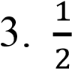 Metre = ______________________cm. (500,50,100,25)

4. Litre = ______________________ ml. (25,250,100,400) Q.(5 &6)Colour to indicate given fraction.

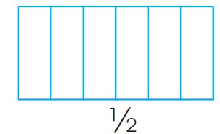 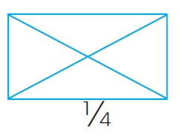

1. Draw a circle of 3 cm and make design in it.

1. Draw four different ways to cut a rectangle into four equal parts (show quartes).

# UNDERSTANDING

Q. (9 &10) Continue the following patterns.

26Z, 25Y, 24X, …………, …………, …………., ……………

123, 234, 345,…………., ……………, …………….., …………………

1. Complete the number tower.

2

4

6

8

1. Razia wants changes for Rs.500 .How many notes will she get

All 100 notes…………..

All 50 notes…………..

All 20 notes…………..

All 5 notes …………….

1. Arrange number 1 to 9 in such a way that numbers on each line add upto 15.

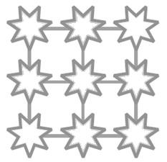

# ABILITY TO COMPUTE

14. One crab has 8 legs, So 3 crabs have…………….legs. 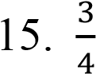of 1 kg=…………….gram(75,750,500,300)

1. Write the secret message in numbers (i.e. A=1,B=2).

RESPECT THE ELDERS HELP THE NEEDY

1. Simran has made a necklace of 18 sea-shells. How many such necklaces can be made using 100 sea-shells.

1. Observe the given circle and answer the question given below.

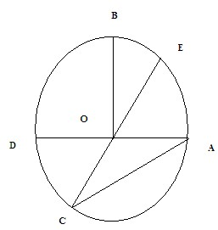 i) Write two radius:______, _______

ii) Write two diameter:_______,_______ iii) Write one chord:________,________

**PROBLEM SOLVING ABILITY**

1. Half of 100 = …………
2. Quarter of 40=………….
3. Arrange 24 glasses in two different way, so that each row has same numbers of glasses.

1. There are 90 students,6 students form one group. So in how many group all the students can be divided ?

1. Look at the pricelist chart and solve the question given below. Find the price of

|  |  |  |
| --- | --- | --- |
| Sl no. | Items | Price per Kg in Rs. |
| 1 | Tomato | 40 |
| 2 | Potato | 20 |
| 3 | Onion | 60 |
| 4 | cauliflower | 30 |

1.  Kg onion=

1. 5 kg potatoes=

1.  kg tomatoes=

1.  kg cauliflower+ kg potatoes=

KENDRIYA VIDYALAYA

FORMATIVE ASSESSMENT- III (2016-17)

CLASS: V TIME: 1 Hr. 30 Min

SUBJECT: MATHS MAX. M: 40

NAME- _______________________________________ DATE: …..................

Class- V Sec___ Roll No._____ Invigilator’s Sign_______ Examiner’s Sign. ……

|  |  |  |  |  |  |
| --- | --- | --- | --- | --- | --- |
| COMPETENCIES | KNOWLEDGE | UNDERSTANDING | ABILTY IN  COMPUTING | PROBLEM SOLVING ABILITY | OVER ALL GRADE |
|  |  |  |  |  |  |

KNOWLEDGE

Q1. Choose the correct answer:

* 1. Five hundredth =____________
     1. 0.5 ii) 0.05 iii) 0.005 iv) 0.0005
  2. Twelve point Zero Two Seven= _________________
     1. 12.027 ii) 12.207 iii) 12.027 iv) 12.702
  3. How many faces has a cube? __________
     1. 5 ii) 6 iii) 8 iv) 12
  4. 1cm = _______ mm
     1. 10 ii) 100 iii) 0.1 iv) 0.01

1. 3 Kg 25 g = ___________Kg

i) 3.250 ii) 325 iii) 0.325 iv)3.025

1. Which of these is the correct Deep drawing of a cube:

c) d)

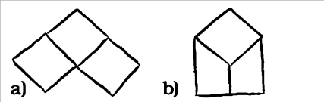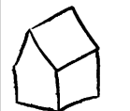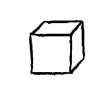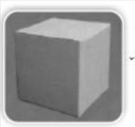

Ans: ………………………………

Q2. Study the Map and answer :

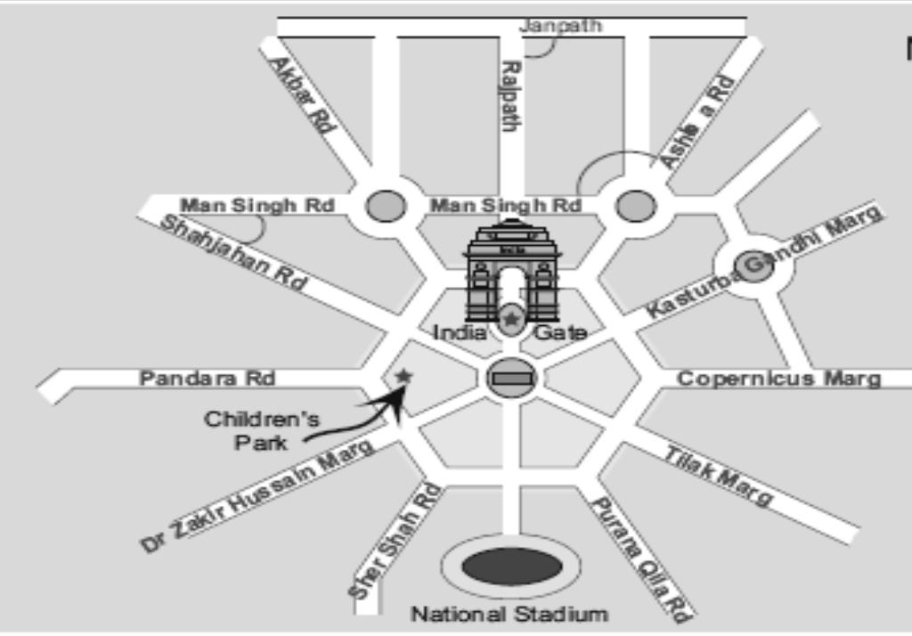

1. Which of the pair of roads cut at right angle:
   1. Man Singh Road and Shahajahan Road
   2. Ashoka Road and Mansingh Road
   3. Janpath and Rajpath

Ans: _______________________________________

1. Which of these roads make the smallest angle between them:

i) Mansingh Road and Sahajan Road. ii) Mansingh Road and Ashoka Road.

iii) Rajpath and Janpath.

Ans: _______________________________________

UNDERSTANDING

Q3. a) Which of the following is the correct Deep Drawing of the given Dice:

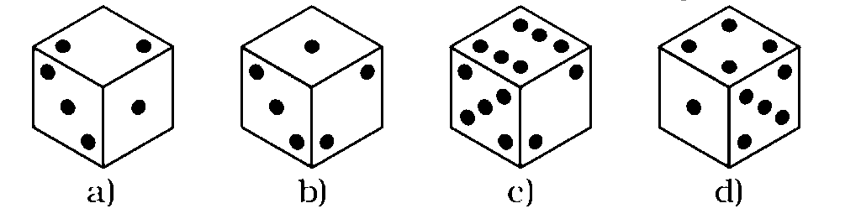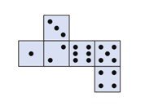

Ans :……….. …………….

|  |  |  |  |  |
| --- | --- | --- | --- | --- |
|  |  |  |  |  |
|  |  |  |  |  |

Colour 0.4 part of the given figure:

Q4.

1. Continue the Pattern:

1 x 1 = 1

11x11 = 121

111x11 = ___________

1111x1111= ____________

1. Draw the Floor Map of the given Deep Drawing:

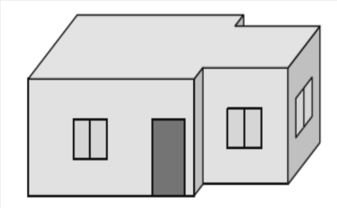

(Deep Drawing) (Floor Map)

Q5. The temperature in the city was noted at 3 pm on 16 Jan 2013.

|  |  |  |
| --- | --- | --- |
| 1. | Srinagar | 8.1C0 |
| 2. | Jaipur | 23.2 C0 |
| 3. | Bhopal | 25.9 C0 |
| 4. | Mumbai | 35.1 C0 |
| 5. | Chennai | 29.9 C0 |

* + 1. Which place had the highest temperature at 3pm?

Ans.______________________________________________

* + 1. How much higher is the temperature in Chennai from that in Bhopal?

Ans.______________________________________________

* + 1. How many degrees will the temperature need to rise for it to reach 40C0 in Mumbai?

Ans.______________________________________________

* + 1. How much lower is the temperature of Jaipur from that in Mumbai?

Ans.______________________________________________

ABILITY TO COMPUTE

Q6. Choose the correct answer:

a) Write in Decimal 2/100 = _________

i) 0.2 ii) 0.02 iii) 0.002 iv) 2.0

b) 1.2 x 100= ____________

i) 1.2 ii) 1.02 iii) 12 iv)120

Q7. a) Calculate:

2.06+ 3.78=_______

9.02- 3.68=_______

b) Write the Secret number: ______

i) It is smaller than Half of Hundred

ii) It is more than 3 Tens and less than 4 Tens.

iii) The Tens digit is Two more than the Ones digit.

iv) Together the digits have a sum of 4.

Q8.Look at the table and answer the following questions:

|  |  |  |
| --- | --- | --- |
| Country | Money | Changed into Indian Rupees |
| China | Yuan | 5.50 |
| South Africa | Rand | 5.18 |
| Korea | Won | 0.04 |
| USA | Dollar | 39.70 |

1. Leena’s mother brought a gift of 40 Rand from South Africa . Find its cost in Indian Rupees.

Ans:

1. Sofia from Korea came to India. She bought a chocolate and gave 500 won to the shopkeeper. How much Indian Rupees she will get back?
2. Ans:

PROBLEM SOLVING ABILITY

Q9.

1. 5 paise = ________ Rupees.
   1. 0.05 ii) 0.005 iii) 0.5 iv) 5
2. The perimeter of a Square having side 1cm is= __________________
   1. 4cm ii) 1cm iii) 2cm iv) 3cm

Q10.

1. The Map distance between two cities is 3.5cm. If the scale is 1cm=100km find out the ground distance between the two cities.

Ans:

1. Find the Area and the Perimeter of the given figure:

Ans: 4m

8m

Q11. The Perimeter of a Rectangular floor is 120 m .If the length of the floor is 45m, then find out the Area of the floor ?

Ans: